Topology optimization for design multiple vibration absorbers
Notes_Absorber_by_TOP.m 1
SDOF main system with absorbers 1
Implementation 7
Unit cell design by topology optimization 8
SDOF main system force input 9

Notes_Absorber_by_TOP.m

SDOF model of a structure
Consider a single-degree-of-freedom (SDOF) system shown below. Let M-10 kg, K=100 N/m, the system has a natural frequency of 10 rad/sec.
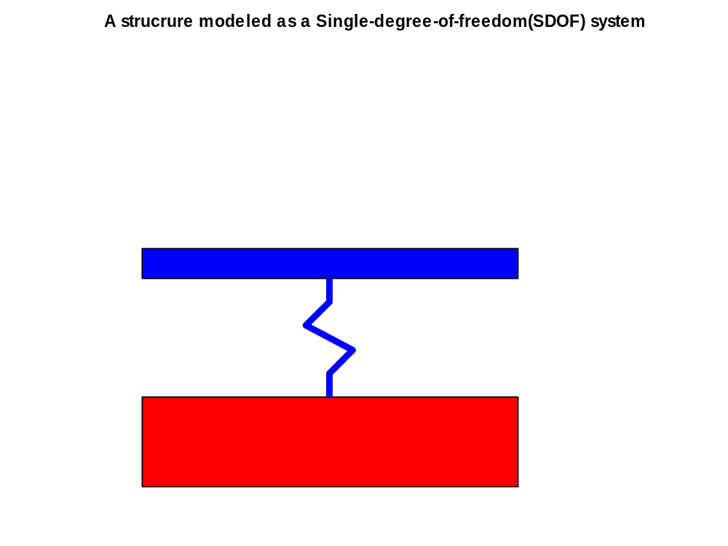

The following figure is the frequency response of the system. If there is no damping, the response has a high peak at the nature frequency.

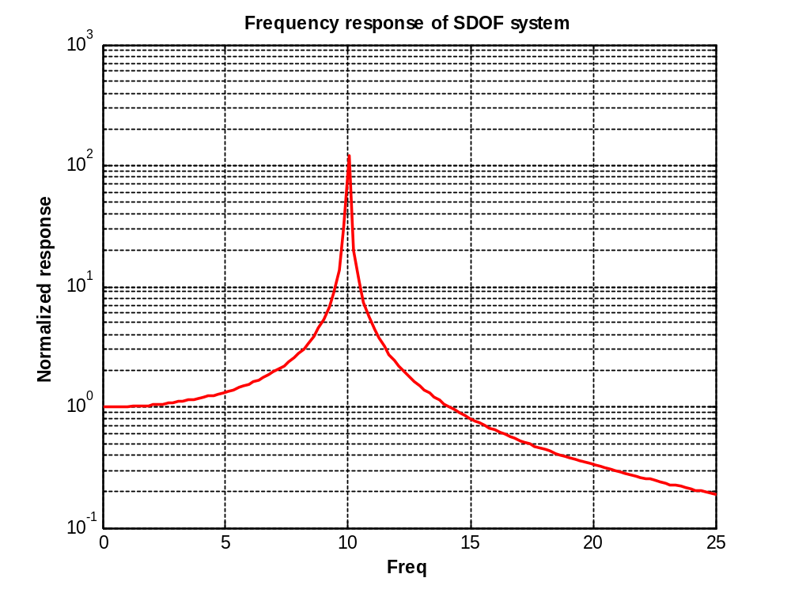Main system with absorbers
One simple way to reduce this response is to attach a undamped absorber with frequency of 10 ras/sec. This effectively produces an anti-resonant frequency at 10 rad/sec and eliminates the high resonsnt response.
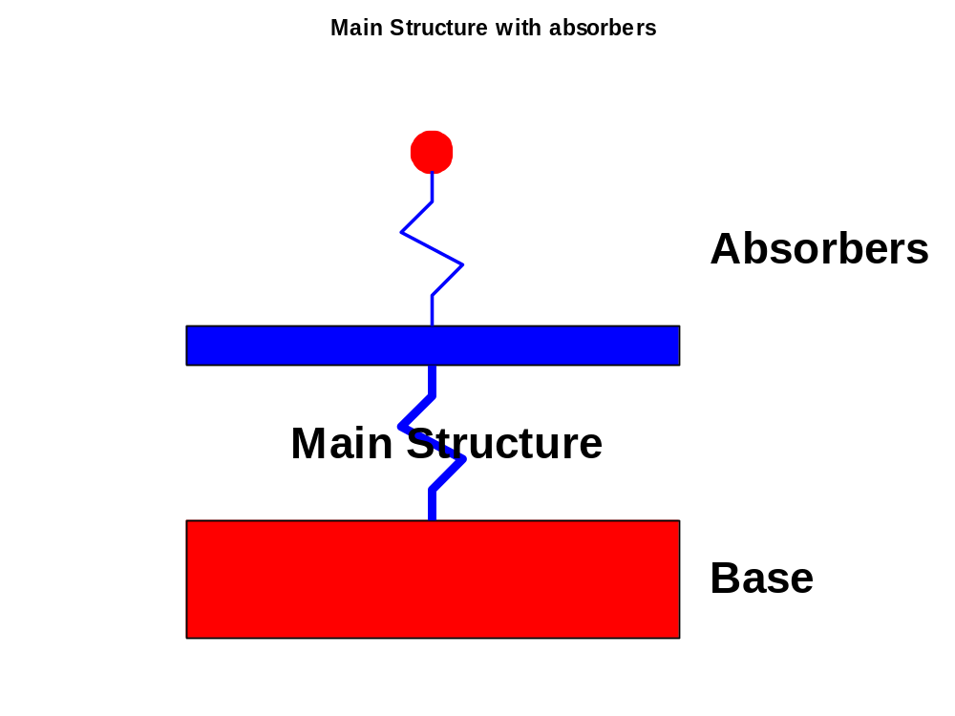
The frequency of the system with and without the absorber are given below. However,the addition of the absorber makes the system 2-dof with natural frequencies at WA and WB. Thus, if the forcing frequency deviates form 10 rad/sec, the response would be high. This is due to the narrow bandwidth of the absorber.(Shown as a short horizintak line). Thus it is desirable to increase the bandwidth for vibration reduction.

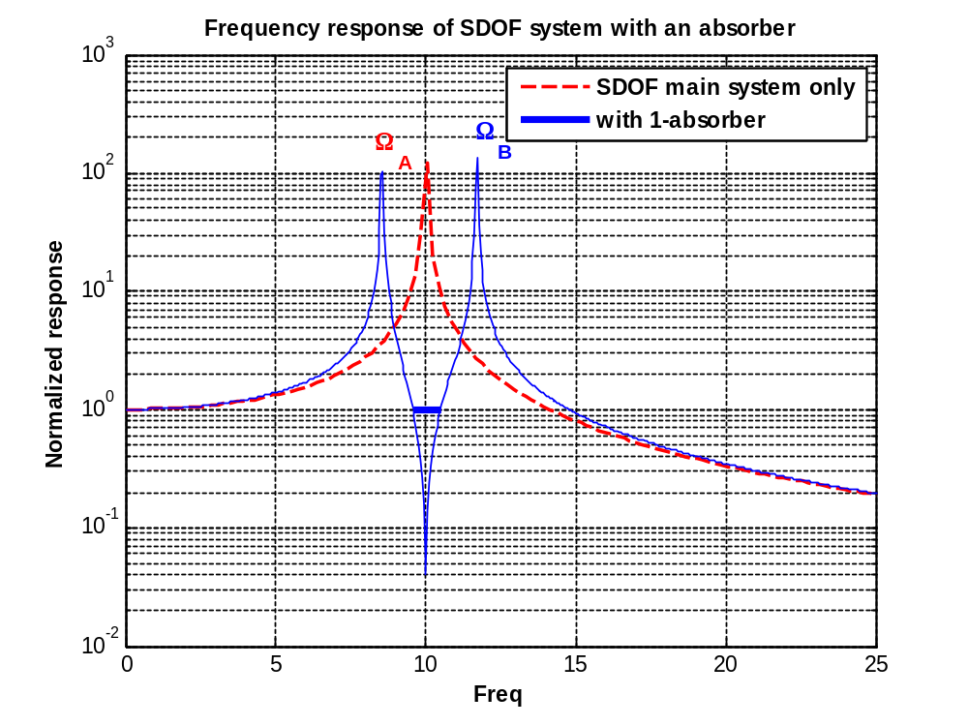

From theory of local modification, we know that when a spring-mass system with natural frequency of WAbs is added to a structuer, all frequency (of the attached structure) below WAbs will decreast while all frequency above WAbs will increase. Thus, if we attach another absorbe with frequency 10 rad/sec, this would make WA smaller and WB larger, consquently, increases the band width of the system.

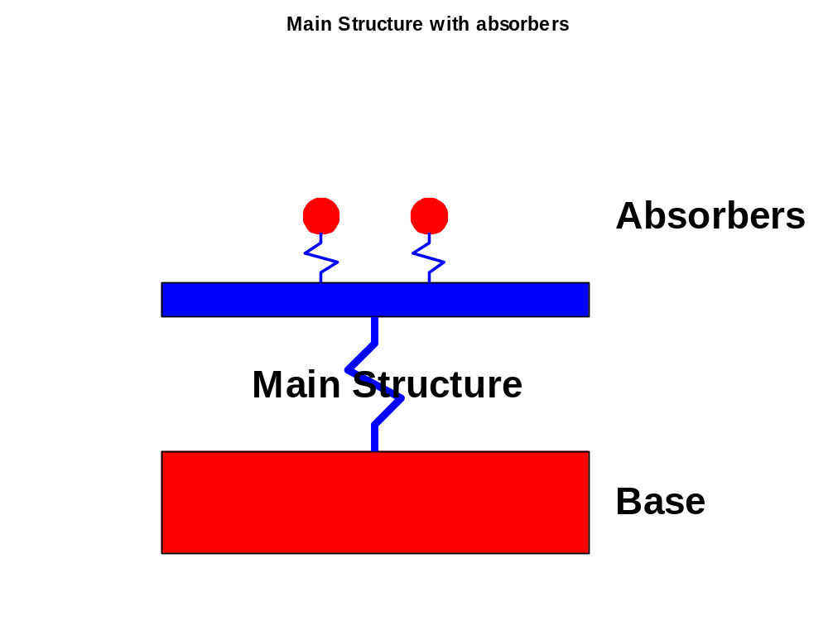
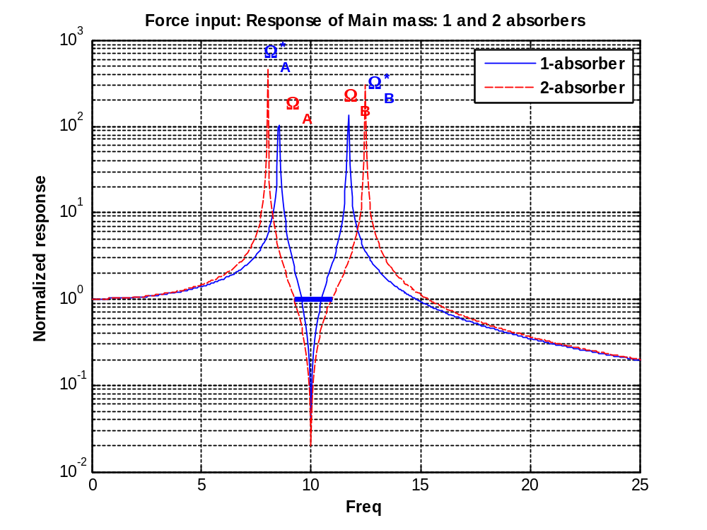
Thus, we can add more absorbers with the same frequency to increase the bandwidth further. The following figure shows the frequency responses of the same main SDOF system with 1, 5, 10 and 20 absorbers.

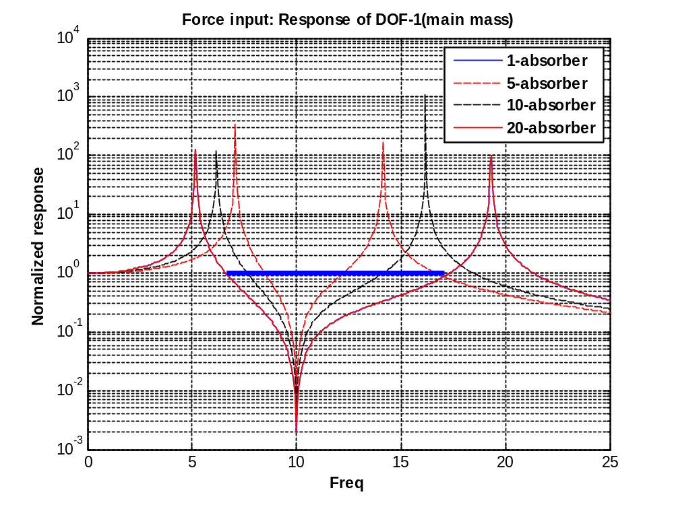

Implementation
Consider the design shown Figure 1.This can be considered as a discrete model of the system shown in Figure 2. We can design the unit cell with desired vibration properties by topology optimization, see Figure 3.

Figure 4 shows a potential applications for design sandwidth plates with vibration reduction capability.

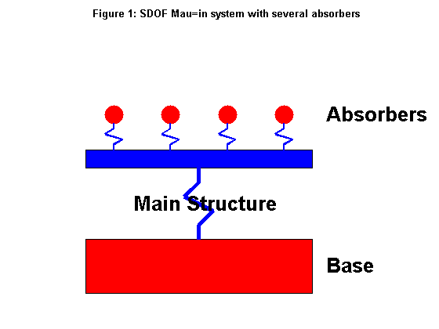
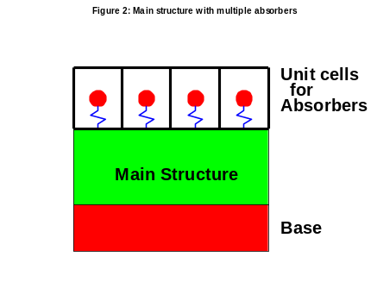

Unit cell design by topology optimization
(For illustration only, the real design will be computed by topology optimization)

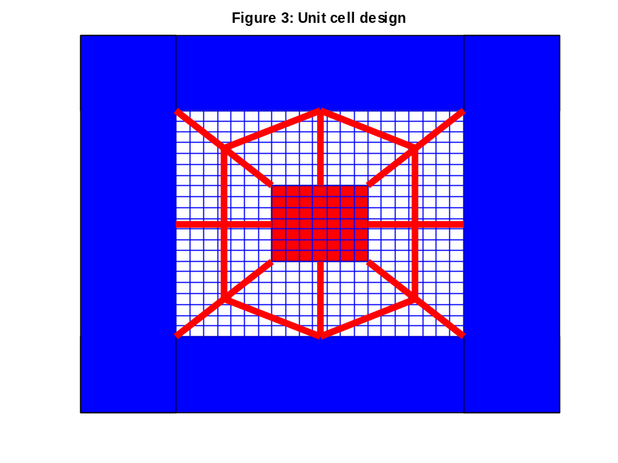

Application

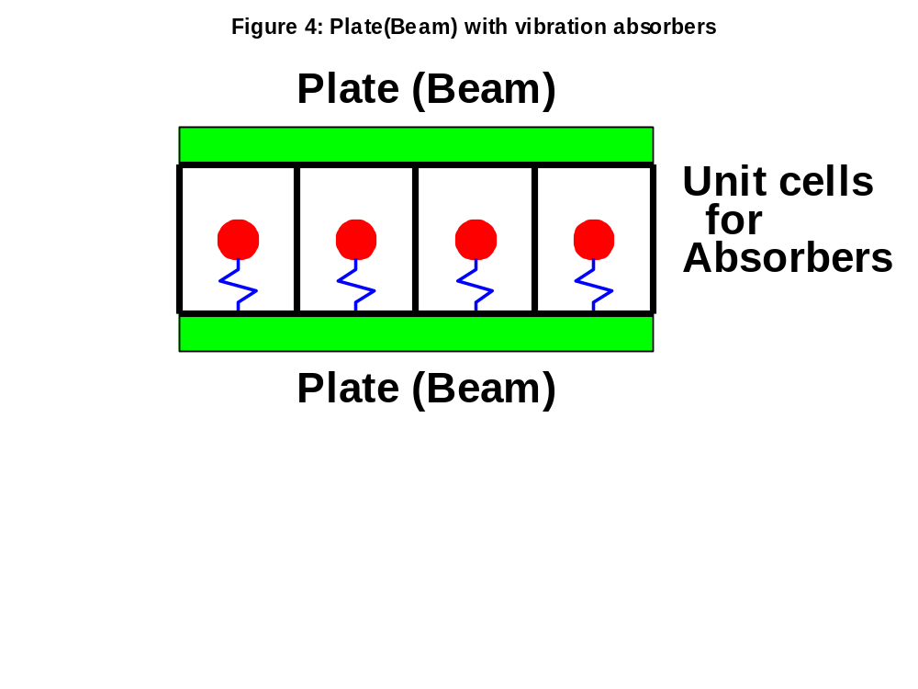
Exension:
- MDOF main sysem
- Damped absorbers
- Groups of absorbers(damped or undamped) wih each group unned to a specific mode of the MDOF main system

